|  |
| --- |
| Experiment No. 9 |
| Program to manipulate arrays using NumPy |
| Date of Performance: |
| Date of Submission: |

**Experiment No. 9**

**Title:** Program to manipulate arrays using NumPy

**Aim:** To study and implement arrays manipulation using NumPy

**Objective:** To introduce NumPy package

**Theory:**

**Numpy**is a general-purpose array-processing package. It provides a high-performance multidimensional array object, and tools for working with these arrays. It is the fundamental package for scientific computing with Python.  
Besides its obvious scientific uses, Numpy can also be used as an efficient multi-dimensional container of generic data.

#### Arrays in Numpy

Array in Numpy is a table of elements (usually numbers), all of the same type, indexed by a tuple of positive integers. In Numpy, number of dimensions of the array is called rank of the array.A tuple of integers giving the size of the array along each dimension is known as shape of the array. An array class in Numpy is called as **ndarray**. Elements in Numpy arrays are accessed by using square brackets and can be initialized by using nested Python Lists.

**Creating a Numpy Array**  
Arrays in Numpy can be created by multiple ways, with various number of Ranks, defining the size of the Array. Arrays can also be created with the use of various data types such as lists, tuples, etc. The type of the resultant array is deduced from the type of the elements in the sequences.  
**Note:** Type of array can be explicitly defined while creating the array.

**Code:**

import numpy as np

# Creating a NumPy array

arr = np.array([1, 2, 3, 4, 5])

print("Original array:", arr)

# Reshaping the array

reshaped_arr = arr.reshape(5, 1)

print("Reshaped array:", reshaped_arr)

# Adding a scalar value to each element of the array

scalar_added_arr = arr + 10

print("Scalar added array:", scalar_added_arr)

# Element-wise multiplication with another array

arr2 = np.array([2, 3, 4, 5, 6])

elementwise_multiplied_arr = arr * arr2

print("Element-wise multiplied array:", elementwise_multiplied_arr)

# Finding the mean of the array

mean = np.mean(arr)

print("Mean of the array:", mean)

# Finding the maximum element in the array

max_element = np.max(arr)

print("Maximum element of the array:", max_element)

# Indexing and slicing

print("First three elements of the array:", arr[:3])

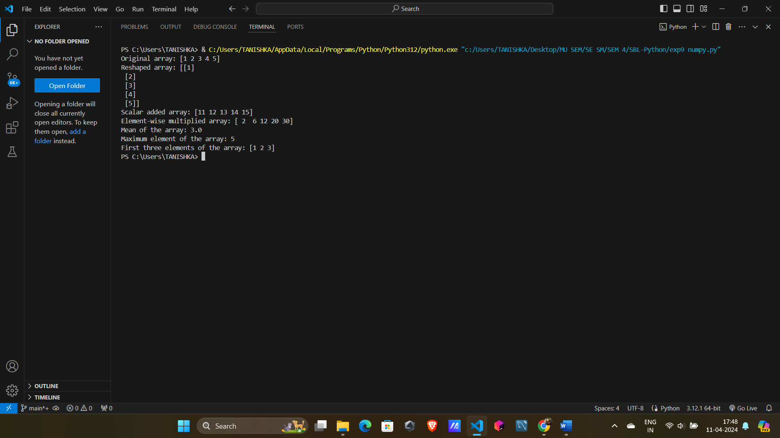**Output:**

**Conclusion:** NumPy package has been studied and arrays have been implemented and manipulated.